BSc Computing with foundation

COM4301 Maths for Computing

Assessment 1

Name Surname : MICHAIL SIDERIS
BoltonID : 2526787
Marking tutor: ARETAKI AIKATERINI
Date of submission: 16/1/2026

Exercise 1:
i)
241/16 | 15(F) | 1
15(F)/16 | 0 | 15(F)
a) 241₁₀=11110001₂=361₈=F1₁₆
240/2 | 120 | 1
120/2 | 60 | 0
60/2 | 30 | 0
30/2 | 15 | 0
15/2 | 7 | 1
7/2 | 3 | 1
3/2 | 1 | 1
1/2 | 0 | 1
241/8 | 30 | 1
30/8 | 3 | 6
3/8 | 0 | 3

3598₁₀=111000001110₂=7016₈=E0E₁₆
3598/16 | 224 | 14(E)
224/16 | 14 | 0
14/16 | 0 | 14(E)

3598/8 | 449 | 6
449/8 | 56 | 1
56/8 | 7 | 0
7/8 | 0 | 7

3598/2 | 1799 | 0
1799/2 | 899 | 1
899/2 | 449 | 1
449/2 | 224 | 1
224/2 | 112 | 0
112/2 | 56 | 0
56/2 | 28 | 0
28/2 | 14 | 0
14/2 | 7 | 0
7/2 | 3 | 1
3/2 | 1 | 1
1/2 | 0 | 1

175627₁₀= 101010111000001011₂=527013⁸=2AE0B₁₆
175627/8 | 21953 | 3
21953/8 | 2744 | 1
2744/8 | 343 | 0
343/8 | 42 | 7
42/8 | 5 | 2
5/8 | 0 | 5
175627/16 | 10976 | 11(B)
10976/16 | 686 | 0
686/16 | 42 | 14(E)
42/16 | 2 | 10(A)
2/16 | 0 | 2

175627/2 | 87813 | 1
87813/2 | 43906 | 1
43906/2 | 21953 | 0
21953/2 | 10976 | 1
10976/2 | 5488 | 0
5488/2 | 2744 | 0
2744/2 | 1372 | 0
1372/2 | 686 | 0
686/2 | 343 | 0
343/2 | 171 | 1
171/2 | 85 | 1
85/2 | 42 | 1
42/2 | 21 | 0
21/2 | 10 | 1
10/2 | 5 | 0
5/2 | 2 | 1
2/2 | 1 | 0
1/2 | 0 | 1

b)
1110111₂= (1*2⁶) + (1*2⁵) + (1*2⁴) + (0*2³) + (1*2²) + (1*2¹) +(1*2⁰) =
= 64 + 34 + 16 + 0 + 4 + 2 + 1 =
= 119
1604₈= (1*8³) + (6*8²) + (0*8¹) + (4*8⁰) =
= 512 + 384 + 0 + 4 =
= 900
Ε0000Ε₁₆= (14*16⁵) + (0*16⁴) + (0*16³) + (0*16²) + (0*16¹) +(E*16⁰)
= (14*1,048,576) + (0*65,536) + (0*4,096) + (0*256) + (0*16) + (14*1)
= 14,680,064 + 14
= 14,680,078

1110111₂= 119₁₀
1604₈= 900₁₀
E0000E₁₆= 14,680,078₁₀

c)
11011 + 01011
11011
+ 01011
------------
100110

1001011 + 11101
1001011
+ 11101
-------------------
1101000

100101 – 11011
100101
- 11011
------------------
001010

1101011 – 111010
1101011
- 111010
----------------------
0110001

ii)
a) 1 1000 ∧ (0 1011 ∨ 1 1011)
(0 1011 V 1 1011):
OR: 1 1011
1 1000 ∧ 1 1011
AND: 1 1000

1 1000 ∧ (0 1011 ∨ 1 1011) = 1 1000

b) (0 1111 ∧ 1 0101) ∨ 0 1000
(0 1111 ∧ 1 0101) =
AND: 0 0101
0 0101 ∨ 0 1000 =
OR: 0 1101

(0 1111 ∧ 1 0101) ∨ 0 1000 = 0 1101

c) (0 1010 ⊕ 1 1011) ⊕ 0 1000
(0 1010 ⊕ 1 1011) =
XOR: 1 0001
1 0001 ⊕ 0 1000 =
XOR: 1 1001

(0 1010 ⊕ 1 1011) ⊕ 0 1000 = 1 1001

d) (1 1011 ∨ 0 1010) ∧ (1 0001 ∨ 1 1011)
(1 1011 ∨ 0 1010) =
OR: 1 1011
(1 0001 ∨ 1 1011) =
OR: 1 1011
1 1011 ∧ 1 1011 =
AND: 1 1011

(1 1011 ∨ 0 1010) ∧ (1 0001 ∨ 1 1011) = 1 1011

Exercise 2
- U={a,b,c,e,f,g,h,k,m}
A={a,b,c}, B={a,c,f,h,m}, C={c,e,g,k,m}, D={a,b} and F={b,c}
First we do the complements in U
A ̅ =U∖A={e,f,g,h,k,m}
B ̅ =U∖B={b,e,g,k}
C ̅ =U∖C={a,b,f,h}

A ̅ ∩B
Elements that are in B but not in A
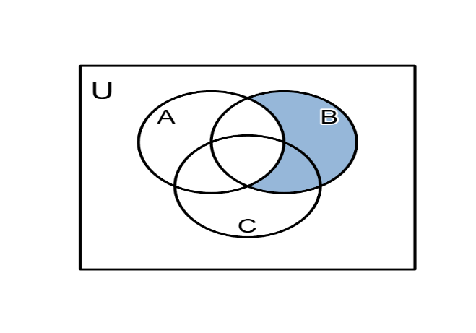
A ̅ ∩B = {e,f,g,h,k,m} ∩ {a,c,f,h,m} = {f,h,m}

A∪C ̅
Everything that is in A OR not in C
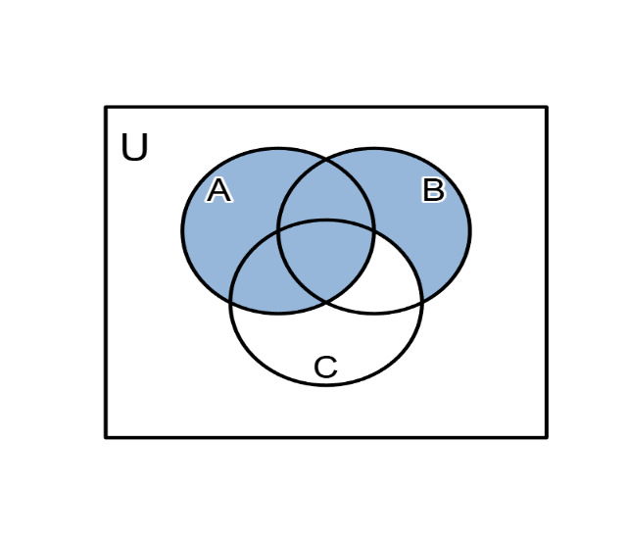
A∪C ̅ = {a,b,c}∪{a,b,f,h} = {a,b,c,f,h}

$\left(A∩\overline{B}\right)∪\left(\overline{A}∩B\right)$
In A but not B, OR in B but not A
$\left(A∩\overline{B}\right)$ = {a,b,c}∩{b,e,g,k}={b}
$\left(\overline{A}∩B\right)$ = {e,f,g,h,k,m}∩{a,c,f,h,m}={f,h,m}
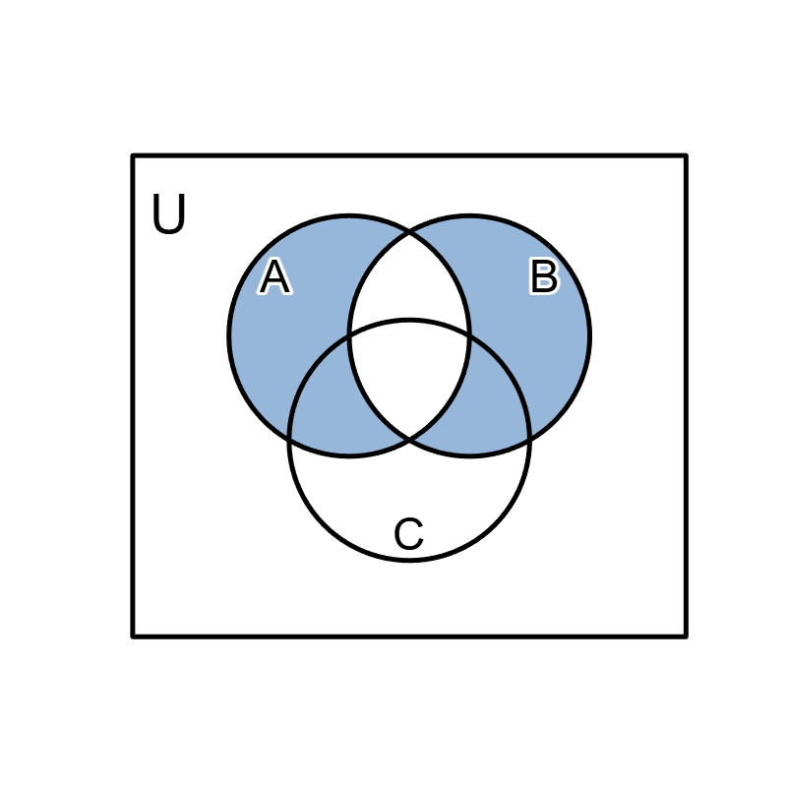
$\left(A∩\overline{B}\right)∪\left(\overline{A}∩B\right)= \{b\}∪\{f,h,m\}=\{b,f,h,m\}$

(A∪C)∖B
Everything in A or C, but remove anything in B
A∪C={a,b,c,e,g,k,m}
{a,b,c,e,g,k,m}∖{a,c,f,h,m}= {b,e,g,k}

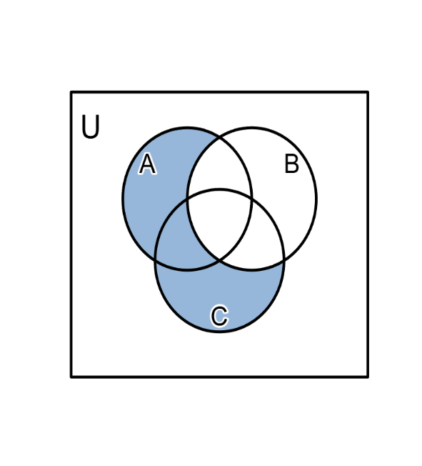
$\left(B∩\overline{C}\right)\backslash A$
In B, not in C, and not in A
$\left(B∩\overline{C}\right)\backslash A$ = {a,c,f,h,m}∩{a,b,f,h}={a,f,h}
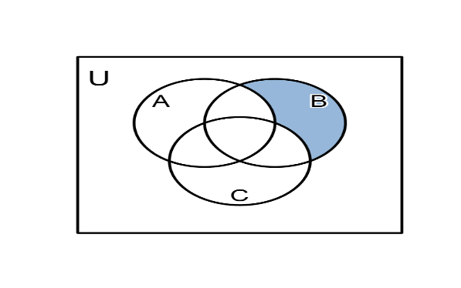
{a,f,h}\{a,b,c} ={f,h}

(D×F)∪(F×D)
D={a,b}
F={b,c}
D×F ={(a,b),(a,c),(b,b),(b,c)}
F×D = {(b,a),(b,b),(c,a),(c,b)}
(D×F)∪(F×D) = {(a,b),(a,c),(b,b),(b,c),(b,a),(c,a),(c,b)}

(D×F)∩(F×D)
# only the pairs that appear in both sets as we see above
{(b,b)}

ii)

$A=\{∅,1,\{2,3\}\}$ and $B=\{2, 3\}$

$a)\left\{1\right\}∈A$ its false because {1} is not an element of A the elements of A are $∅,1,\{2,3\}$
b) $\left\{1\right\}⊂A$ its true because the only element of {1} is 1 and because 1 is an element of A then every {1} is in A
c) $B∈A$ its true because B = {2,3} and {2,3} is in A
d) B⊂A its false because even though B = {2,3} is in A whats inside the curly brackets isn’t
e) $∅∈A$ its true because the empty set is an element of A
f) $∅⊂A$ its true because the empty set is a subset of all sets

Exercise 3
i)
a) $p→¬q$
p | q | $$¬q$$ | $$p→¬q$$
T | T | F | F
T | F | T | T
F | T | F | T
F | F | T | T

It’s a contingent as its neither a tautology nor a contradiction

b) ¬p↔q
p | q | $$¬q$$ | ¬p↔q
T | T | F | F
T | F | F | T
F | T | T | T
F | F | T | F

It’s a contingent as its neither a tautology nor a contradiction

$c) \left(p→q\right)∧(p∧¬q)$

p | q | $$p→q$$ | ¬q | p∧¬q | $$\left(p→q\right)∧(p∧¬q)$$
T | T | T | F | F | F
T | F | F | T | T | F
F | T | T | F | F | F
F | F | T | T | F | F

It’s a contradiction because its always False

$d) \left(p↔q\right)∨(¬p↔q)$
p | q | p↔q | ¬p | ¬p↔q | $$\left(p↔q\right)∨(¬p↔q)$$
T | T | T | F | F | T
T | F | F | F | T | T
F | T | F | T | T | T
F | F | T | T | F | T
It’s a tautology because its always True

$e)(¬p∧(p∨q))→q$
p | q | $$¬p$$ | $$p∨q$$ | $$¬p∧(p∨q)$$ | $$(¬p∧(p∨q))→q$$
T | T | F | T | F | T
T | F | F | T | F | T
F | T | T | T | T | T
F | F | T | F | F | T

It’s a tautology because its always T

$f) (p∨q)∧r$
p | q | r | $$p∨q$$ | $$(p∨q)∧r$$
T | T | T | T | T
T | T | F | T | F
T | F | T | T | T
T | F | F | T | F
F | T | T | T | T
F | T | F | T | F
F | F | T | F | F
F | F | F | F | F
It’s a contingent as its neither a tautology nor a contradiction
ii)$(p∨q)∧r$ ≡ $\left(p∧r\right)∨(q∧r)$
p | q | r | $$p∨q$$ | $$(p∨q)∧r$$ | $$p∧r$$ | $$q∧r$$ | $$\left(p∧r\right)∨(q∧r)$$
T | T | T | T | T | T | T | T
T | T | F | T | F | F | F | F
T | F | T | T | T | T | F | T
T | F | F | T | F | F | F | F
F | T | T | T | T | F | T | T
F | T | F | T | F | F | F | F
F | F | T | F | F | F | F | F
F | F | F | F | F | F | F | F

Its logically equivalent because the truth values on the 5th column are the same as the 8th column

Exercise 4
a) $p→q$
b) $¬q⟷r$
c) $q→¬r$
d) $p∨q∨r$
e) $(p→¬r)∨(q→¬r)$
f ) $(p∧q)∨(¬q∧r)$
a) If you have the flu then you miss the final examination
b) You do not miss the final examination if and only if you pass the course
c) If you miss the final examination then you do not pass the course
d) You have the flu or you miss the final examination or you pass the course
e) Either if you have the flu then you do not pass the course or if you miss the final examination then you do not pass the course
f) Either you have the flu and miss the final examination or you do not miss the final examination you pass the course

I came to this conclusion by understanding and using the logical symbols
¬p means negation
p ∧ q means conjunction
p ∨ q means disjunction
p → q means implication
p ⟷ q biconditional

Exercise 5

$$\left\{\begin{aligned}x-3y=-3 \\ x+y=5\end{aligned}\right.$$

Algebraic solution:

$$\left\{\begin{aligned}x-3y=-3 \\ x+y=5\end{aligned}\right.$$

(x +y) – (x – 3y) = 5 – (-3)
x + y – x + 3y = 8
4y = 8
y=2

x + 2 = 5
x = 3

(x,y) = (3,2)

Graphical solution:
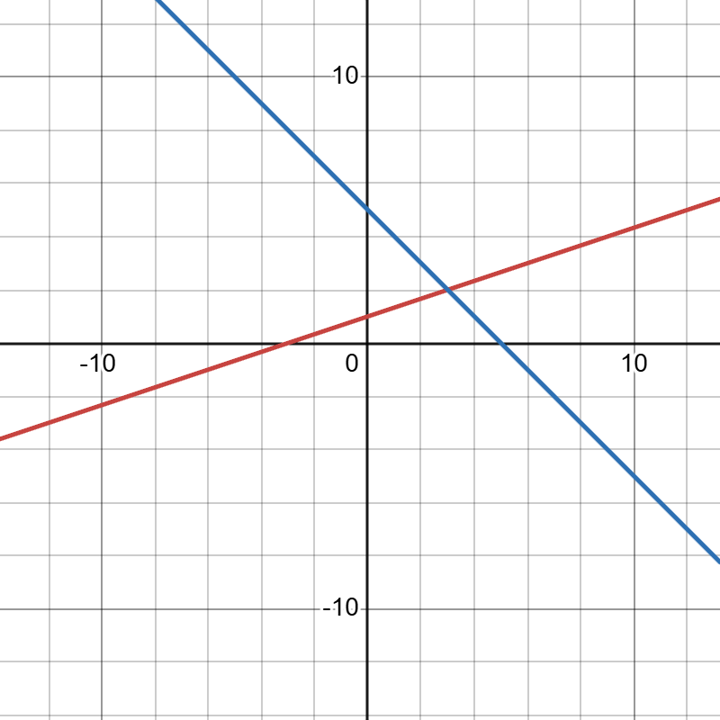

The lines meet at point (3,2)

Exercise 6

$$\left\{\begin{aligned}7x-8y+5z=5 \\ -4x+5y-3z=-3 \\ x-y+z=0\end{aligned}\right.$$

D = 7 - 8 5
-4 5 -3
1 -1 1
D=7(minor1​)−(−8)(minor2​)+5(minor3​)
Minor of 7
(5)(1)−(−3)(−1)=
5 – 3 =2

Minor of -8
(−4)(1)−(−3)(1)=
-4 + 3 = -1

Minor of 5
(−4)(−1)−(5)(1)=
4 - 5= -1

D=7(2)−(−8)(−1)+5(−1)
D= 14 -8 -5 =
D= 1 ≠0

Dx= 5 -8 5
-3 5 -3​
0 -1 1

Dx​=5(2)−(−8)(−3)+5(3)
Dx​=10−24+15=1
x =$\frac{Dx}{D}$=$\frac{1}{1}$=1

Dy = 7 5 5
-4 -3 -3
1 0 1
Dy​=7(−3)−5(−1)+5(3)
Dy​=−21+5+15=−1
y = $\frac{Dy}{D}$ = $\frac{-1}{1}$ = -1

Dz = 7 -8 5
-4 5 -3
1 -1 0
Dz​=7(−3)−(−8)(3)+5(−1)
Dz​=−21+24−5=−2
z = $\frac{Dz}{D}$ $\frac{-2}{1}$ = -2

x=1 , y = -1 , z = -2

Exercise 7
A = {1,2,3,4}, B = {a,b,c,d}
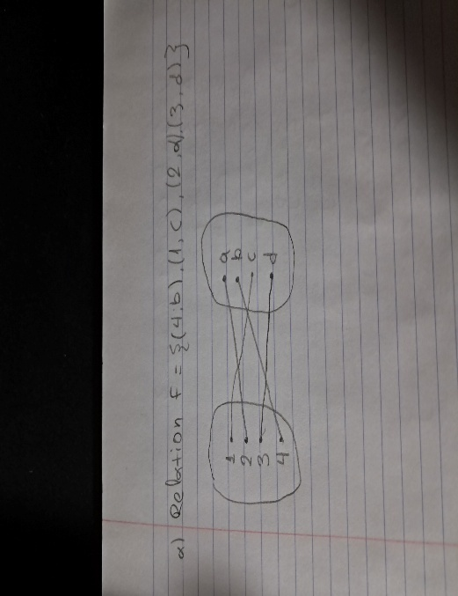
a) f = {(4, b), (1, c), (2, a), (3, d)}

Is a function because all elements of A are used
Domain = {1,2,3,4}
Range = {a,b,c,d}

b) g = {(2, d), (4, a), (3, c), (1, a)}
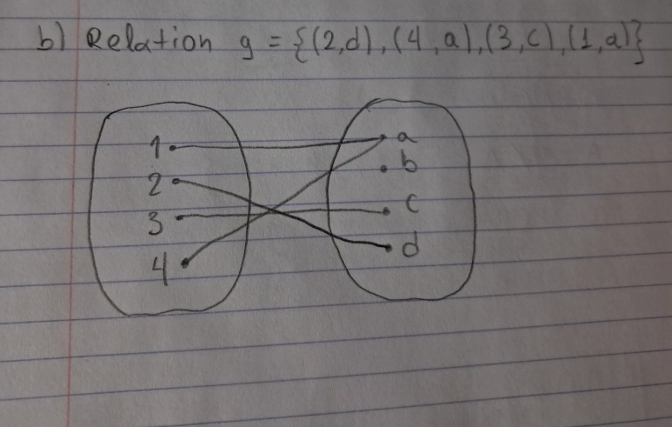

Is a function because all elements of A are used
Domain = {1,2,3,4}
Range = {a,b,c}
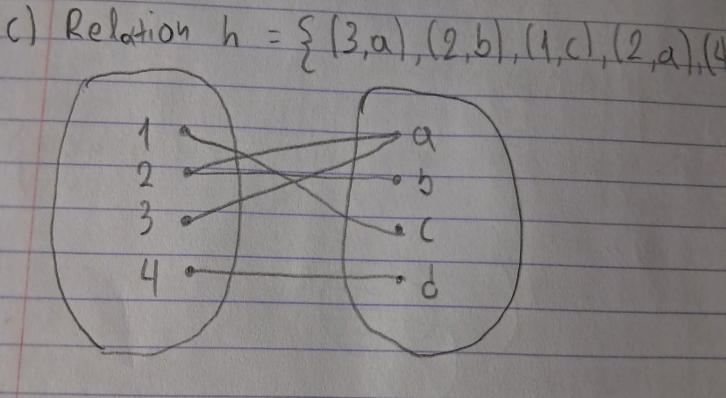
c) h = {(3,a) , (2, b) , (1, c), (2 , a) , ( 4, d)}

Is not a function because one element of A is used for two elements of B
2->a and 2->b
$$d) s=\{\left(1,d\right), \left(4,a\right), (2,c)\}$$
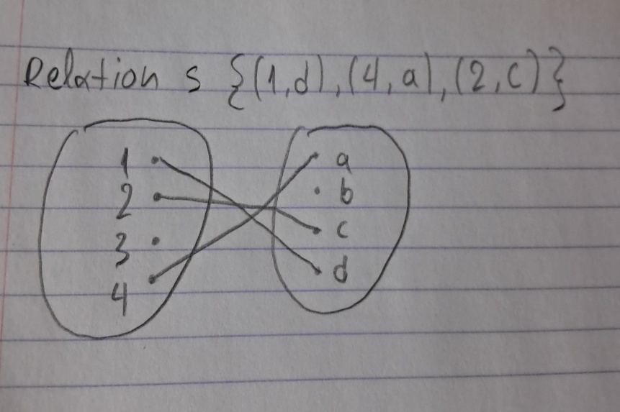

Is not a function because element 3 of A is not used

So function are relation f and relation g while relation h and relation s are not

Exercise 8

(x1​,x2​,x3​,x4​,x5​) xi ∈ {0,1}
a)
∣S∣=$2^{5}$=32​
b)
If component 1 and 2 are working then we have x1 = 1 and x2 = 1
​(1,1,0,0,0),(1,1,0,0,1),(1,1,0,1,0),(1,1,0,1,1),(1,1,1,0,0),(1,1,1,0,1),(1,1,1,1,0),(1,1,1,1,1)
If component 3 and 4 are working then we have x3 =1 and x4 = 1
(0,0,1,1,0),(0,0,1,1,1),(0,1,1,1,0),(0,1,1,1,1),(1,0,1,1,0),(1,0,1,1,1),(1,1,1,1,0),(1,1,1,1,1)
If component 1 , 3 and 5 are working then we have x = 1 , x3 = 1 , x5 = 1
(1,0,1,0,1),(1,0,1,1,1),(1,1,1,0,1),(1,1,1,1,1)
W={(1,1,0,0,0),(1,1,0,0,1),(1,1,0,1,0),(1,1,0,1,1),(1,1,1,0,0),(1,1,1,0,1),(1,1,1,1,0),(1,1,1,1,1),(0,0,1,1,0),(0,0,1,1,1),(0,1,1,1,0),(0,1,1,1,1),(1,0,1,1,0),(1,0,1,1,1)}

c)
if x4 = 0 and x5 = 0
then
∣A∣=$2^{3}$=8​
A = (0,0,0,0,0)(0,0,1,0,0)(0,1,0,0,0)(0,1,1,0,0)(1,0,0,0,0)(1,0,1,0,0)(1,1,0,0,0)(1,1,1,0,0)​
d)
Event A ∩ W contains outcomes where x4 = 0 and x5 = 0 and system works
A∩W={(1,1,0,0,0),(1,1,1,0,0)}
W={(1,1,0,0,0),(1,1,0,0,1),(1,1,0,1,0),(1,1,0,1,1),(1,1,1,0,0),(1,1,1,0,1),(1,1,1,1,0),(1,1,1,1,1),(0,0,1,1,0),(0,0,1,1,1),(0,1,1,1,0),(0,1,1,1,1),(1,0,1,1,0),(1,0,1,1,1)}
A = (0,0,0,0,0)(0,0,1,0,0)(0,1,0,0,0)(0,1,1,0,0)(1,0,0,0,0)(1,0,1,0,0)(1,1,0,0,0)(1,1,1,0,0)

Exercise 9
n = 25
a)
Mean:
xˉ=$\frac{Σx}{25}$=$\frac{2082}{25}$​=83.28 months
Range :
Maximum – minimum = 483 – 5 = 478 months
Variance:
x | x − x̄ | (x − x̄)²
5 | -78.28 | 6127.76
7 | -76.28 | 5818.64
12 | -71.28 | 5080.84
14 | -69.28 | 4799.72
14 | -69.28 | 4799.72
14 | -69.28 | 4799.72
18 | -65.28 | 4251.48
21 | -62.28 | 3878.8
22 | -61.28 | 3755.24
23 | -60.28 | 3633.68
24 | -59.28 | 3514.12
25 | -58.28 | 3396.56
34 | -49.28 | 2428.52
34 | -49.28 | 2428.52
37 | -46.28 | 2141.84
47 | -36.28 | 1316.24
49 | -34.28 | 1175.12
64 | -19.28 | 371.72
67 | -16.28 | 265.08
69 | -14.28 | 203.92
125 | 41.72 | 1740.56
192 | 108.72 | 11819.04
229 | 145.72 | 21234.32
453 | 369.72 | 136693.92

∑(x−xˉ)2=395,460.96
$s^{2}$ = $\frac{∑\left(x-xˉ\right)2}{n-1}$=$\frac{395,460.96}{24}$ = 16,477.54

$s^{2}$ = 16,477.54
b)
Sorted data:
5,7,12,14,14,14,18,21,22,23,24,25,34,34,37,47,49,64,67,69,125,192,229,453,483
n = 25 then median = 13th value
$Q_{2}$= 34
$Q_{1}$ = $\frac{14+18}{2}$ = 16
$Q_{3}$ = $\frac{67+69}{2}$ = 68
So the 5 number summary is:
Minimum = 5
$Q_{1}$ =16
Median = $Q_{2}$ = 34
$Q_{3}$ = 68
Maximum = 483
And the IQR is :
IQR = $Q_{3}$ - $Q_{1}$ = 68 – 16 = 52

c)
Q1 - 1.5 x IQR and Q3 + 1.5 x IQR
Lower bound:
Q1 - 1.5 x IQR = 16 – 78 = -62
Upper bound:
Q3 + 1.5 x IQR = 68 + 78 = 146
Values outside the interval [ - 62, 146] are considered outliers
d)
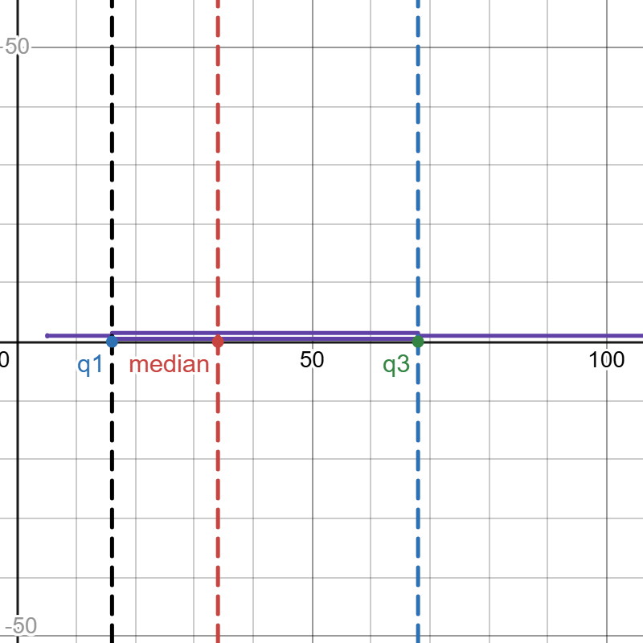
The median is closer to Q1 rather than Q3 and the distribution has long tail after Q3

Exercise 10
P(A) = 0.5
P(B) = 0.1
P(C) = 0.4

P(Def |A) = 0.005
P(Def |B) = 0.001
P(Def |C) = 0.01

P(Def) = P(Def |A) P(A) + P(Def |B) P(B) + P(Def |C) P(C)=
P(Def) = (0.005)(0.5) + (0.001)(0.1) + (0.1)(0.4)=
P(Def) = 0.0025 +0.0001 +0.004 = 0.0066

Bayes theory
P(A |Def) =$\frac{P(Def |A) P(A)}{P(Def)}$
P(B |Def) =$\frac{P(Def |B) P(B)}{P(Def)}$
P(C |Def) =$\frac{P(Def |C) P(C)}{P(Def)}$

a)
P(A |Def) =$\frac{0.005*0.5}{0.0066}=$ $\frac{0.0025}{0.0066}$≈ 0.379

b)
P(B |Def) =$\frac{0.001*0.1}{0.0066}=\frac{0.0001}{0.0066}$≈0.015
c)
P(C |Def) =$\frac{0.1*0.4}{0.0066}$=$\frac{0.004}{0.0066}$≈0.606

References:
1. Hicks, M. (2004) Problem Solving and Decision Making: Hard, Soft and Creative approaches. 2nd edition. Boston: Cengage Learning
2. Kurgalin, S. & Borzunov, S. (2018) The discrete math workbook: a companion manual for practical study. Cham: Springer
3. O'Regan, G. (2018) Guide to Discrete Mathematics: An Accessible Introduction to the History, Theory, Logic and Applications. New York City: Springer
4. Velleman, D. (2019) How to Prove It: A Structured Approach (3rd ed.). Cambridge: Cambridge University Press

​

​
​

